**Amber Poteet**

**Lab 3: The Normal Probability Distribution**

**Section: Friday @ 1:30**

**Exercise 1**

**Script**

#Amber Poteet Lab 3: Normal Probability Distribution

#Question 1

rm(list=ls())

u<- 100

o2<-400

o<- sqrt(o2)

#set q values

q<-seq(u-4*o,u+4*o,by=0.1)

#find values for pdf and plot

pdf<-dnorm(q,u,o)

plot(pdf~q,xlab="Length of Lizards (cm)",ylab= "Probability Density",main="PDF of Lizard Lengths",type="l")

#find values for cdf and plot

cdf<-pnorm(q,u,o)

plot(cdf~q, xlab="Length of Lizards (cm)",ylab= "Probability",main="CDF of Lizard Lengths",type="l")

**Output**

Plot the probability density function of lizard lengths

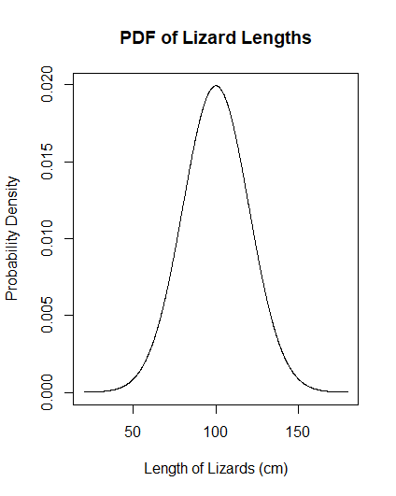

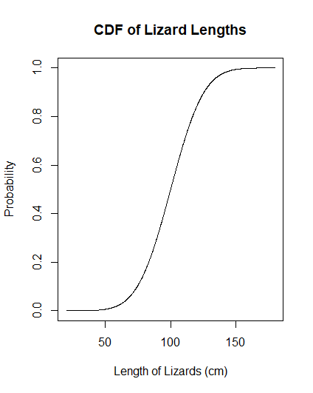Plot the cumulative distribution function of lizard lengths

**Exercise 2**

**Script**

#Amber Poteet Lab 3: Normal Probability Distribution

#Question 2

rm(list=ls())

u<- 100

o2<-400

o<- sqrt(o2)

#prob density for a lenght of 75 cm

dnorm(75,u,o)

#prob that a lizard will be less than or equal to 75 cm

pnorm(75,u,o)

#greater than 120 cm

1-pnorm(120,u,o)

#between 95 cm and 115 cm

pnorm(115,u,o)-pnorm(95,u,o)

#at least 40 cm different from the mean

less<-pnorm(u-40,u,o)

more<-1-pnorm(u+40,u,o)

less+more

#closer than 1.3 o to the mean

pnorm(u-1.3*o,u,o)+pnorm(u-1.3*o,u,o)

#further than 1.5o from the mean

pnorm(u+1.5,u,o)

#further than 0.7o below the mean

1-pnorm(u-0.7,u,o)

#quartiles of the distribution 25%,50%.75%

qnorm(0.25,u,o)

qnorm(0.5,u,o)

qnorm(0.75,u,o)

#2/3 of observation lie below what value?

qnorm(2/3,u,o)

#80% of observations are expected to lie about what value

qnorm(0.80,u,o)

**Output**

What is the probability density for a length of 75 cm?

0.009132454

What is the probability that a lizard will be less than or equal to 75 cm?

0.1056498

Greater than 120?

0.1586553

Between 95 and 115 cm?

0.372079

At least 40 cm different from the mean?

0.04550026

Closer than 1.3  from the mean?

0.193601

Further than 1.5  from the mean?

0.5298926

Further than 0.7  below the mean?

0.519601

What are the quartiles of the distribution?

25%- 86.5102 cm

50%- 100 cm

75%- 113.4898 cm

2/3 of observations are expected to lie below what value?

108.6145 cm

80% of observations are expected to lie above what value?

116.8324

**Exercise 3**

**Script**

**Output**

Plot of 3 PDF’s in same graph with Legend

Plot of 3 CDF’s with Legend

**Exercise 4**

**Script**

**Output**

If the mean height of British men is 177 cm, with a standard deviation of 7.1 cm, what proportion of British men are excluded from being spies by this height restriction? Assume that height follows a normal distribution.

The mean height of British women is 163.3 cm, with a standard deviation of 6.4 cm. Assuming a normal distribution of female height, what fraction of women meet MI5’s height standard?

Imagine that MI5 wants to change its maximum height for female spies. Its goal is to exclude the same proportion of women as men. What should the new maximum height for women be? (Round your answer to the nearest centimeter.)

Sean Connery, the original James Bond, is 183 cm tall. By how many standard deviations does he exceed the height limit for spies?

**Exercise 5**

**Script**

**Output**

What is the probability that a normal random variable will have a value within 1 standard deviation of the mean?

What is the probability that it will be within 5 standard deviations of the mean?

Fill in the blank: A normal random variable has a 50% probability of lying within____ standard deviations of the mean.

Fill in the blank: A normal random variable has a 95% probability of lying within____ standard deviations of the mean.

Fill in the blank: A normal random variable has a 99% probability of lying within____ standard deviations of the mean.